# New (Unreported) Claims Registration

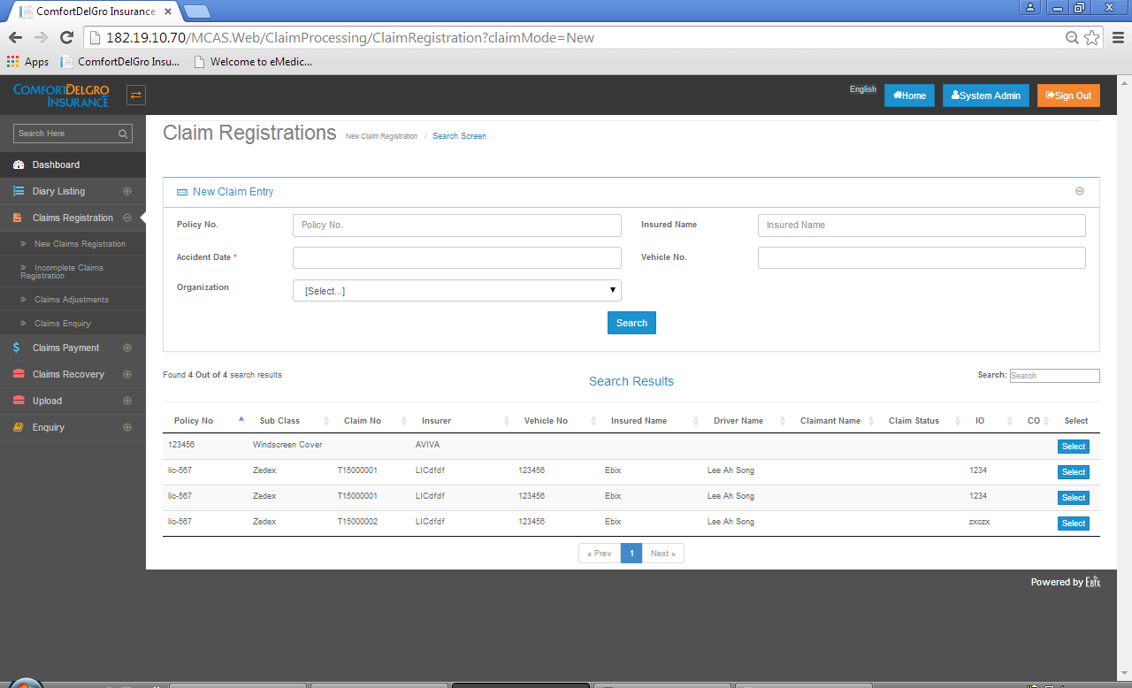

System needs to cater for creating Unreported Claims for all Business Units.

Requirements / Changes Needed:

1. Remove the Current Screens (as shown above) for New Claims Registration
2. When user clicks on the New Claims Registration, it will bring user to the Accident Tab Screen as shown below:

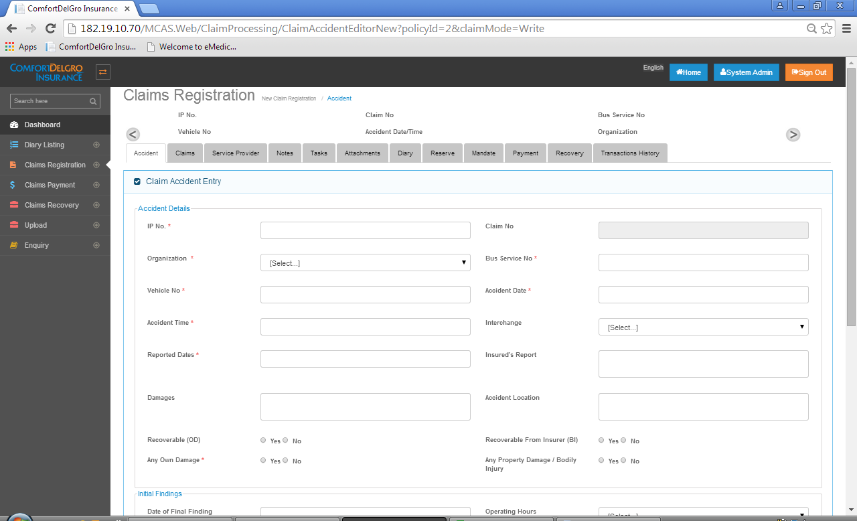

1. To cater for different business units, user must select the Organization first (suggestion: we can lock all fields first and open only the Organization Field for selection or we can show a warning message to prompt user to select the Organization first).
2. If they select Organization that belongs to a Bus and Train, the screen will refresh and current Accident Screen and the rest of the tabs will show the screens that belong to the Bus and Train Business Category.
3. If other Business Organizations are selected (e.g. Taxi or Commercial Vehicles), the screen will refresh to show the screens that are for the related business organization. (Note that screens for other business categories will only be created in Phase 2 after the Bus and Train Category has been rolled out).
4. Upon clicking Save, an Unreported Claim Number will be generated and this Claim will flow to the Incomplete Claim Registration Section where user can retrieve in later stage to continue working on it.